**Exercise 1**

Find the R(t) and MTTF for the system whose reliability diagram is given below. In calculating. MTTF, assume all components are identical and fail randomly with failure rate λ.

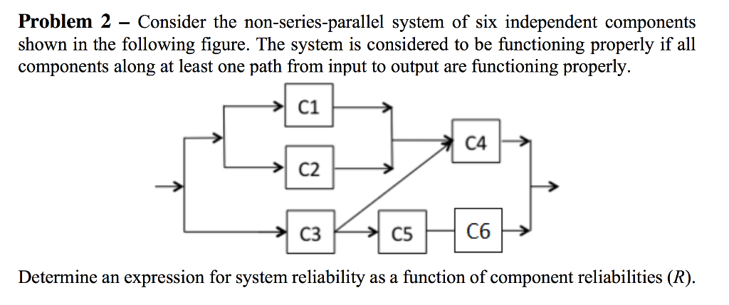

**Exercise 2**

We want to compare two different schemes of increasing reliability of a system using redundancy. Suppose that the system needs *s* identical components in series for proper operation. Further suppose that we are given (*m x s*) components. Given that the reliability of an individual component is R, derive the expressions for the reliabilities of two configurations. For *m* = 2 and *s* =4, compare the two expressions as function of a mission time t.

Let MTTF of the component be 800 hours.

Out of the two schemes shown in the figure below, which one will provide a higher reliability? Modify the scheme that has lower reliability in order to reach the same reliability of the other given the above MTTf (800 h).

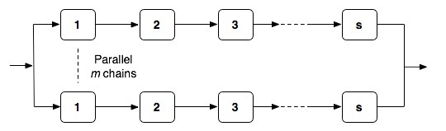

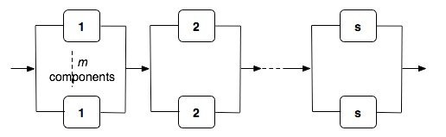

**Exercise 3**

The architecture of a network of computers in a banking system is shown below. The architecture is called a skip-ring network and is designed to allow processors to communicate even after node failures have occurred. For example, if node 1 fails, node 8 can bypass the failed node by routing data over the alternative link connecting nodes 8 and 2. Assuming the links are perfect and the nodes each have a reliability of Rm, derive and expression for the reliability of the network. If Rm obeys the exponential failure law and the failure rate of each node is 0.005 failures per hour, determine the reliability of the system at the end of a 48-hour period.



**Exercise 4**

A data center relies on a cooling system to maintain optimal operating temperatures for its servers. The cooling system is composed of the following components:

* Main Cooling Unit (C): Provides primary cooling. MTTFC=10000h
* Backup Cooling Unit (B): Activates only if the Main Cooling Unit fails. MTTFB=5000h
* Power Supply (P): Provides power to the cooling units. MTTFP=7000h
* Control Panel (CP): Monitors and manages the cooling process. MTTFCP=6000h

​

The cooling system operates as follows.

The Main Cooling Unit and the Power Supply must work together in series for primary cooling.

If the Main Cooling Unit fails, the Backup Cooling Unit activates, provided the Power Supply is still operational.

The Control Panel must always function.

1. **Draw the RBD.**

Represent the system as an RBD, showing the series and parallel arrangements, including the redundancy of the cooling units.

1. **Calculate System Reliability.**

Compute the overall reliability of the cooling system.

1. **Impact of Redundancy:**

Discuss how the addition of the Backup Cooling Unit affects the system reliability compared to a simplex system (without redundancy for the cooling units).

Calculate the system reliability and visualize how the reliability changes with varying MTTFB values.

**Exercise 4**

The system shown in the figure below is a processing system for a helicopter. The system has dual-redundant processors and dual-redundant interface units. Two buses are used in the system, and each bus is also dual-redundant. The interesting part of the system is the navigation equipment. The aircraft can be completely navigated using the Inertial Navigation System (INS). If the INS fails, the aircraft can be navigated using the combination of the Doppler and the altitude heading and reference system (AHRS). The system contains three AHRS units, of which only one is needed. This is an example of functional redundancy where the data from the AHRS and the Doppler can be used to replace the INS, if the INS fails. Because of the other sensors and instrumentation, both buses are required for the system to function properly regardless of which navigation mode is being employed.

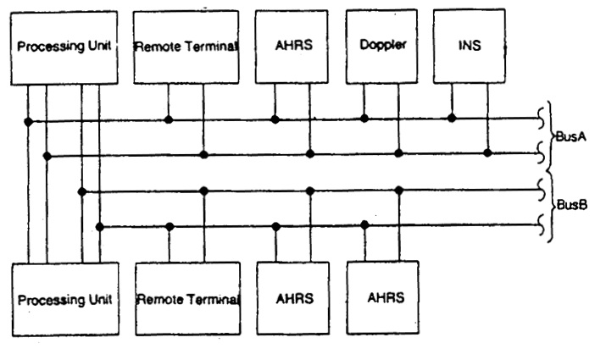

a)  Draw the reliability block diagram of the system.

b) Draw the Fault Tree of the system and analyze the minimal cutsets.

c)  Calculate the reliability for a one-hour flight using the MTTF figures given in the table below. Assume that the exponential failure low applies and that the fault coverage is perfect.

|  |  |
| --- | --- |
| Equipment | MTTF (hr) |
| Processing Unit | 10000 |
| Remote Terminal | 4500 |
| AHRS | 2000 |
| INS | 2000 |
| Doppler | 500 |
| Bus | 60000 |

d) Repeat (c), but this time, incorporate a coverage factor for the fault detection and reconfiguration of the processing units. Using the same failure data, determine the approximate fault coverage value that is required to obtain a reliability (at the end of one hour) of 0.99999.